--a: Chef - Show me the salary of each chef listed in the table. ensure the salary is displayed in irish pounds.

--Irish pounds don't exist since like 2000 and in the original text they refer to the euro. I'm going to assume you mean the euro.

CREATE FUNCTION dbo.fn_ChefSalary()
RETURNS TABLE
AS
RETURN
(

SELECT chef_id, chef_type, FORMAT(salary, 'C', 'de-de') as Salary
FROM Chefs
);

SELECT *
FROM dbo.fn_ChefSalary()

--B.

-- Shows each kitchen’s basic details and sorts by location_id.
SELECT
location_id,
name AS kitchen_name,
address,
num_stoves,
created_at
FROM dbo.Locations
ORDER BY location_id;

--C.

-- Create a function named fn_MenuPrice.
-- This function shows the menu item name and price from the Recipes table
CREATE FUNCTION dbo.fn_MenuPrice()
RETURNS TABLE
AS
RETURN
(
-- Select only unique rows so duplicates do not show more than once.
-- Rename the columns to make the results easy to read.
SELECT DISTINCT
Name AS MenuItem,
Price AS MenuPrice
FROM dbo.Recipes
);
GO

-- Run the function and show all results.
SELECT *
FROM dbo.fn_MenuPrice();
GO

--D.

--Drop the function if it already exists
IF OBJECT_ID('dbo.fn_OrderDistribution', 'IF') IS NOT NULL
DROP FUNCTION dbo.fn_OrderDistribution;
GO

--Recreate the function
CREATE FUNCTION dbo.fn_OrderDistribution()
RETURNS TABLE
AS
RETURN
(
SELECT
order_method AS OrderMethod,
COUNT(*) AS OrderCount
FROM dbo.Orders
GROUP BY order_method

UNION ALL

SELECT
'All' AS OrderMethod,
COUNT(*) AS OrderCount
FROM dbo.Orders
);
GO

--Test the function
SELECT *
FROM dbo.fn_OrderDistribution();
GO

--e: Show me the reservations and how many patrons recieve their favorite table and those that don't.

--I actually need to add table num to orders to make this work

--.... and muck around adding dummy data since I don't want to muck around with getting a LLM to do it.
--Not very hard to do by hand anyways so long as I follow the scheme GPT used for reservations.

ALTER TABLE ORDERS
ADD tablenumber int;

CREATE FUNCTION dbo.fn_TablePreference()
RETURNS TABLE
AS
RETURN
(

SELECT c.name, CASE WHEN r.table_number = o.tablenumber AND r.location_id = o.location_id THEN 'TRUE' else 'FALSE' end as GotPreferred,
r.customer_id, r.location_id, r.table_number AS preferredTable, o.order_id, o.tablenumber as actualTable
FROM Reservations r JOIN Customers c on r.customer_id = c.customer_id JOIN Orders o ON c.customer_id = o.customer_id
WHERE r.reservation_id IS NOT NULL

);

SELECT *
FROM dbo.fn_TablePreference()

A.Function Creation
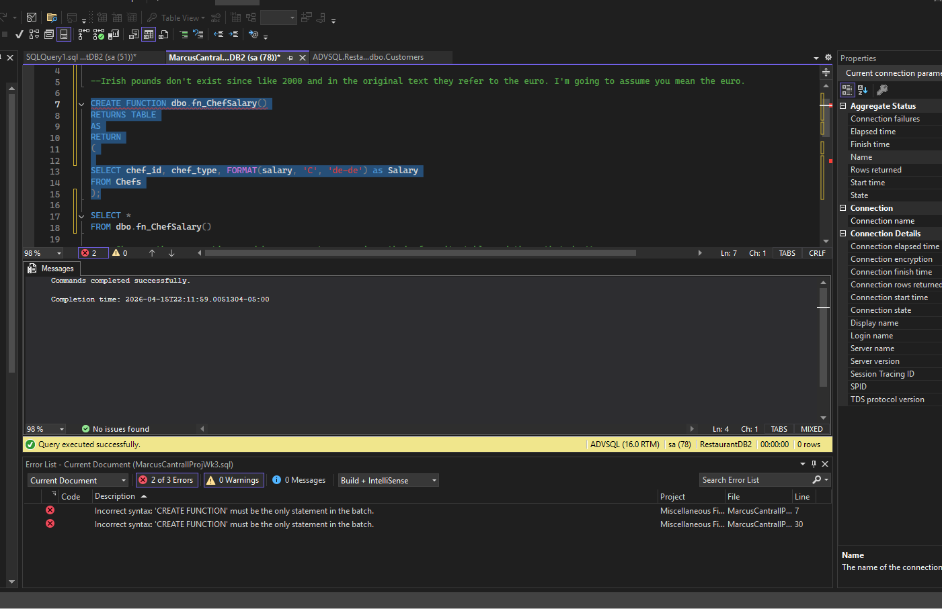
(Has error message because it doesn’t understand that I’m running the create statements as separate batches and not just hitting “RUN QUERY” and doing everything)

A.Function Testing
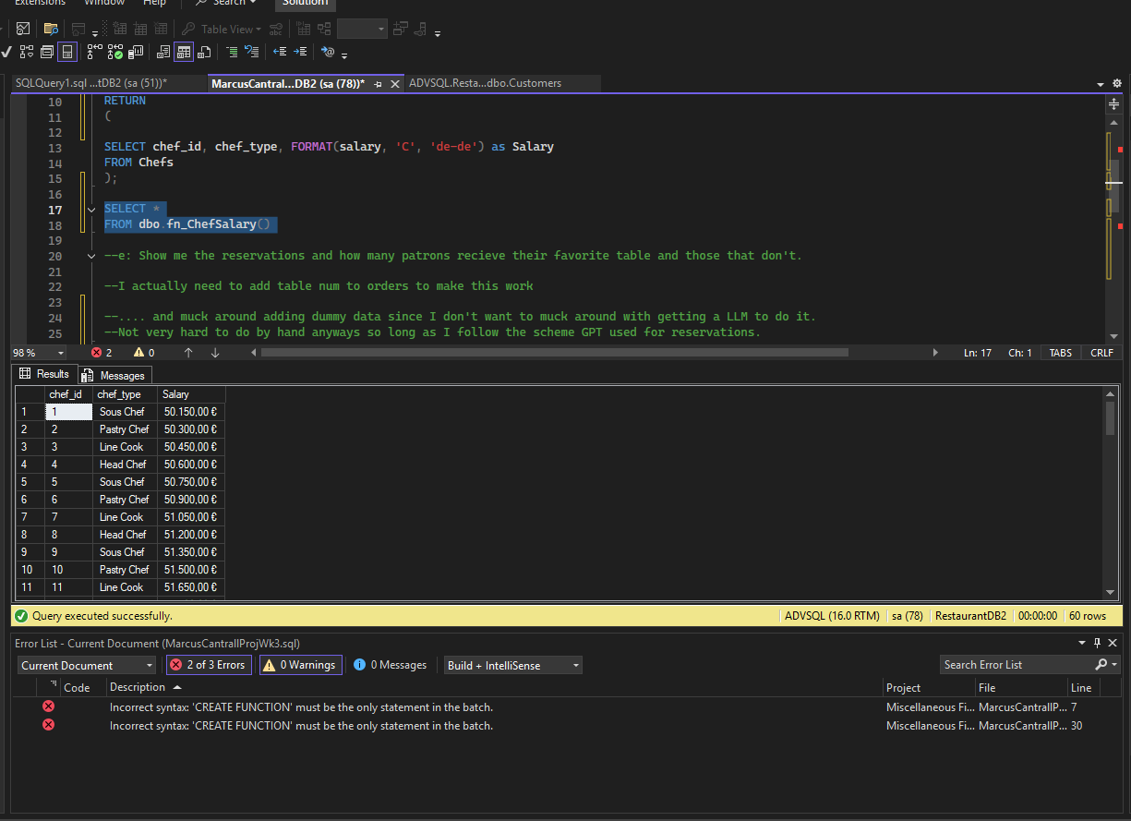

B.
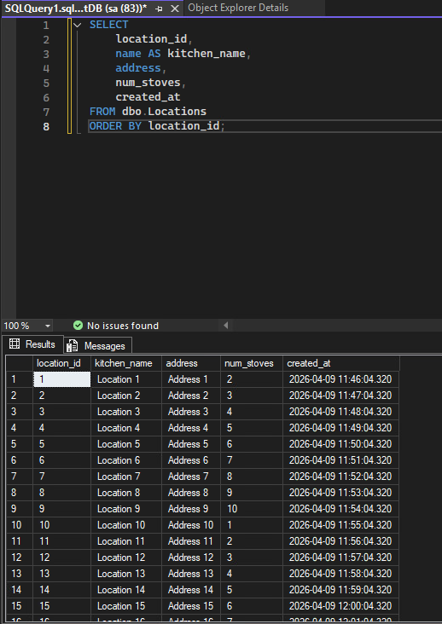
C.
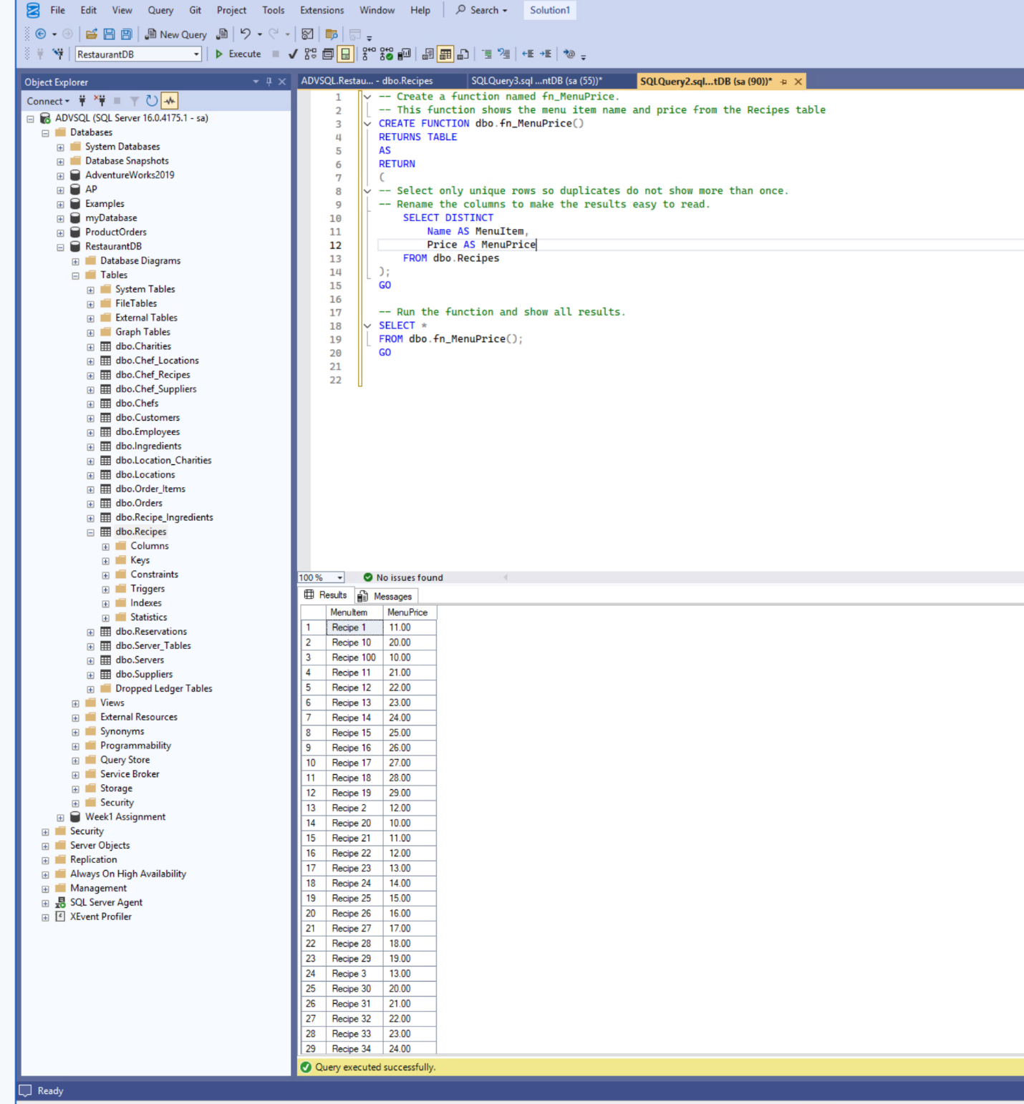
D.
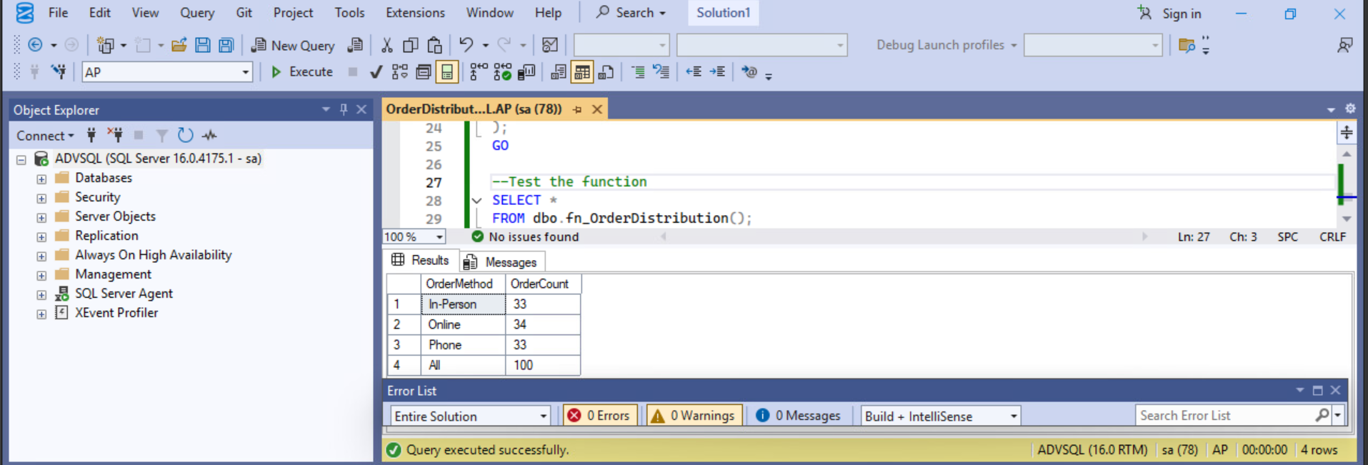

E. Function Creation
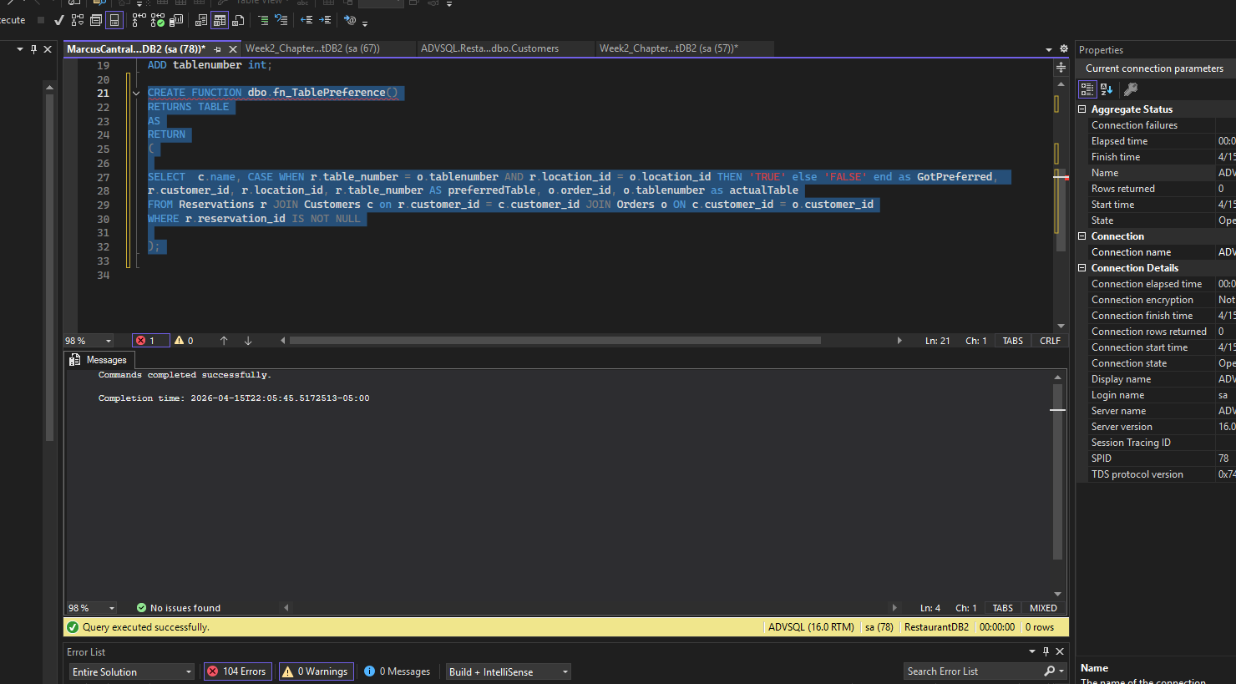

E. Function Testing
